**HADOOP 3.4.1 STEP BY STEP INSTALLATION ON UBUNTU 24.04.1 LTS**

Hardware specification:

**OS:** Ubuntu 24.04.1 LTS

**Memory:** 4 GB

**CPU:** 2 cores

**Storage:** 25 GB

Prerequisites:

Java Development Kit (JDK)

SSH key pair

Hadoop version 3.4.1

**STEP 1: Install JDK**

# *apt install openjdk-8-jdk*

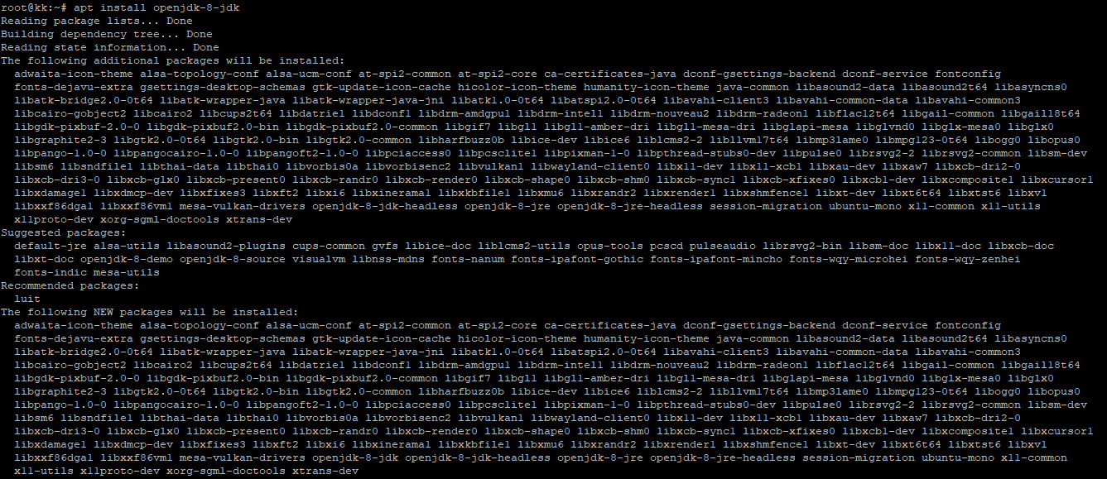

**STEP 2: Generate SSH key pair from “hadoop” user**

**STEP 3: Install Hadoop**

# *wget https://dlcdn.apache.org/hadoop/common/hadoop-3.4.1/hadoop-3.4.1.tar.gz*

**Extract folder and rename**

# *tar -xvzf hadoop-3.4.1.tar.gz*

# *mv hadoop-3.4.1 hadoop*

**Setup Hadoop and Java Environment variables**

# *nano ~/.bashrc*

export JAVA_HOME=/usr/lib/jvm/java-8-openjdk-amd64   
export HADOOP_HOME=/home/hadoop/hadoop export HADOOP_INSTALL=$HADOOP_HOME   
export HADOOP_MAPRED_HOME=$HADOOP_HOME   
export HADOOP_COMMON_HOME=$HADOOP_HOME   
export HADOOP_HDFS_HOME=$HADOOP_HOME   
export HADOOP_YARN_HOME=$HADOOP_HOME   
export HADOOP_COMMON_LIB_NATIVE_DIR=$HADOOP_HOME/lib/native   
export PATH=$PATH:$HADOOP_HOME/sbin:$HADOOP_HOME/bin   
export HADOOP_OPTS="-Djava.library.path=$HADOOP_HOME/lib/native"

**Load the configuration in the current environment**

# *source ~/.bashrc*

**STEP 3: Configure Hadoop environment variable file**

Edit the **$HADOOP_HOME/etc/hadoop/hadoop-env.sh** file to configure **JAVA_HOME**



Add **export JAVA_HOME=/usr/lib/jvm/java-8-openjdk-amd64**

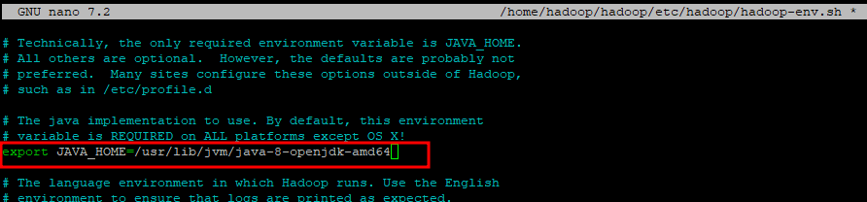

Create directory for **namenode** and **datanode**



Edit the **$HADOOP_HOME/etc/hadoop/core-site.xml** file and update with your system hostname

Add below line

**<configuration>  
 <property>  
 <name>fs.defaultFS</name>  
 <value>hdfs://localhost:9000</value>  
 </property>  
</configuration>**

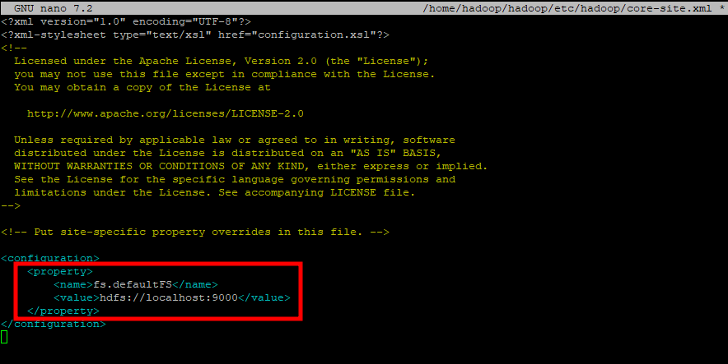

Edit the **$HADOOP_HOME/etc/hadoop/hdfs-site.xml** file and change the namenode and datanode directory paths



Add below line

**<configuration>  
 <property>  
 <name>dfs.replication</name>  
 <value>1</value>  
 </property>  
 <property>  
 <name>dfs.namenode.name.dir</name>  
 <value>file:///home/hadoop/hadoopdata/hdfs/namenode</value>  
 </property>  
 <property>  
 <name>dfs.datanode.data.dir</name>  
 <value>file:///home/hadoop/hadoopdata/hdfs/datanode</value>  
 </property>  
</configuration>**

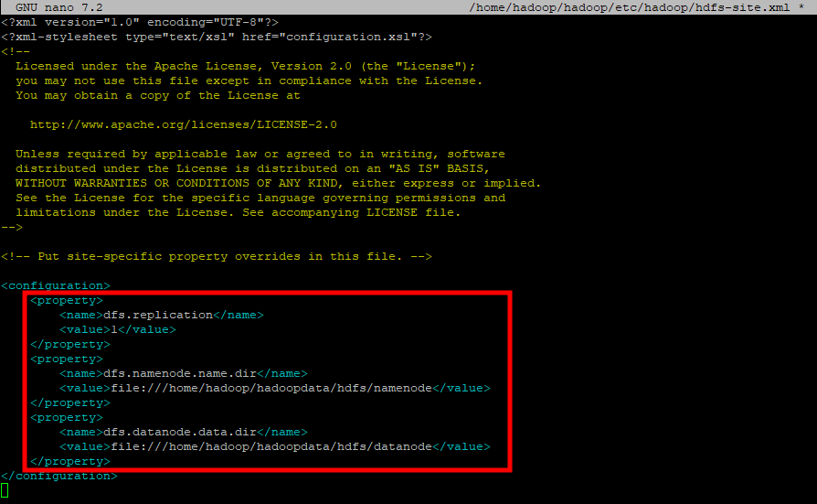

Edit the **$HADOOP_HOME/etc/hadoop/mapred-site.xml** file 

Add below line

**<configuration>  
 <property>  
 <name>yarn.app.mapreduce.am.env</name>  
 <value>HADOOP_MAPRED_HOME=$HADOOP_HOME/home/hadoop/hadoop/bin/hadoop</value>  
 </property>  
 <property>  
 <name>mapreduce.map.env</name>  
 <value>HADOOP_MAPRED_HOME=$HADOOP_HOME/home/hadoop/hadoop/bin/hadoop</value>  
 </property>  
 <property>  
 <name>mapreduce.reduce.env</name>  
 <value>HADOOP_MAPRED_HOME=$HADOOP_HOME/home/hadoop/hadoop/bin/hadoop</value>  
 </property>  
</configuration>**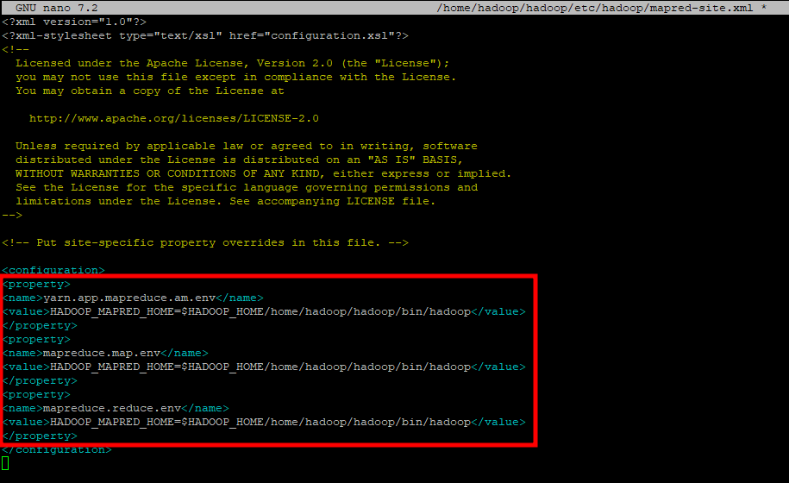

Edit the **$HADOOP_HOME/etc/hadoop/yarn-site.xml** file



Add below line

**<configuration>  
 <property>  
 <name>yarn.nodemanager.aux-services</name>  
 <value>mapreduce_shuffle</value>  
 </property>**

**</configuration>**

**STEP 4: Start Hadoop Cluster**

Format the Hadoop Namenode

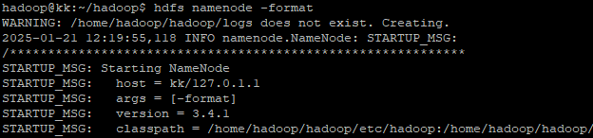

Initiate the Hadoop cluster with **start-all.sh**

Verify running status of Hadoop services

*# jps*

**STEP 5: Access Dashboard**

**DATANODE**

**NAMENODE**

**STEP 6: Create directories in HDFS filesystem**

# *hdfs dfs -mkdir /kaushal*



Browse file

